2021 Real Deal Scholarship Winners

Graduate Scholarship Winner 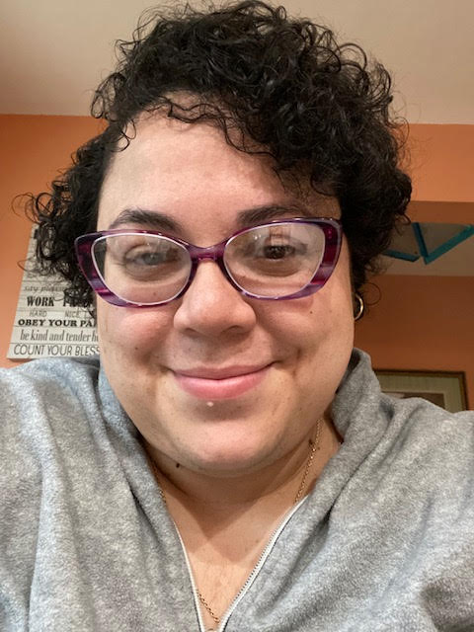
Tasha Robles – University of Illinois at Urbana Champaign

Undergraduate Scholarship Winner
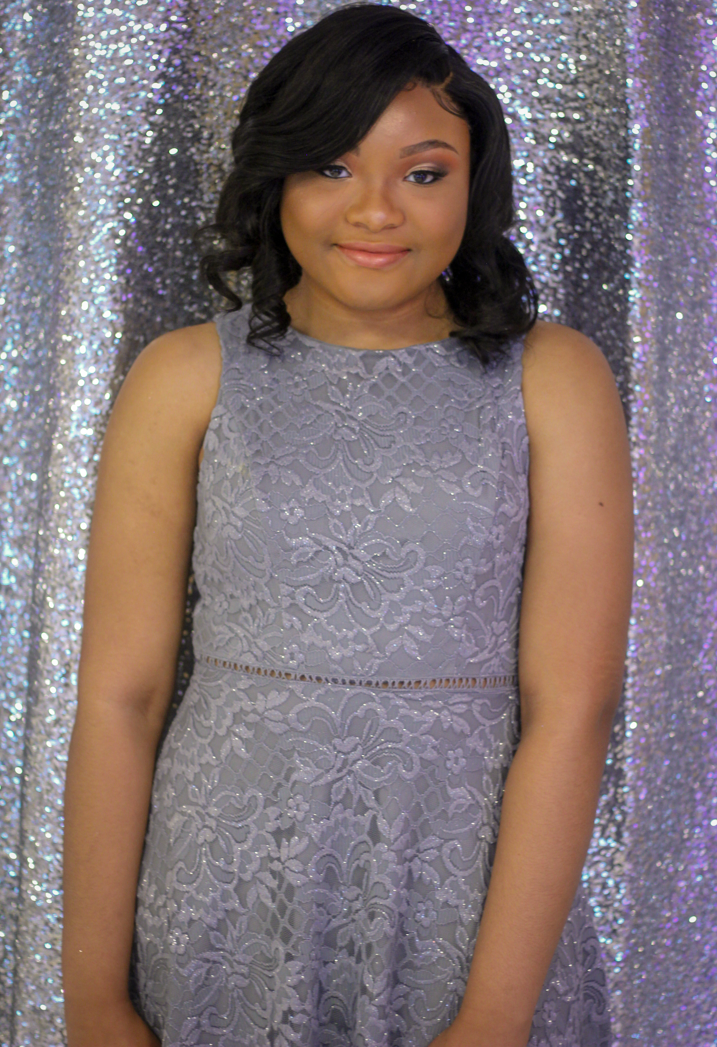
Aliyah Seals – Moraine Valley Community College
2021 High School Graduate Scholarship Winner

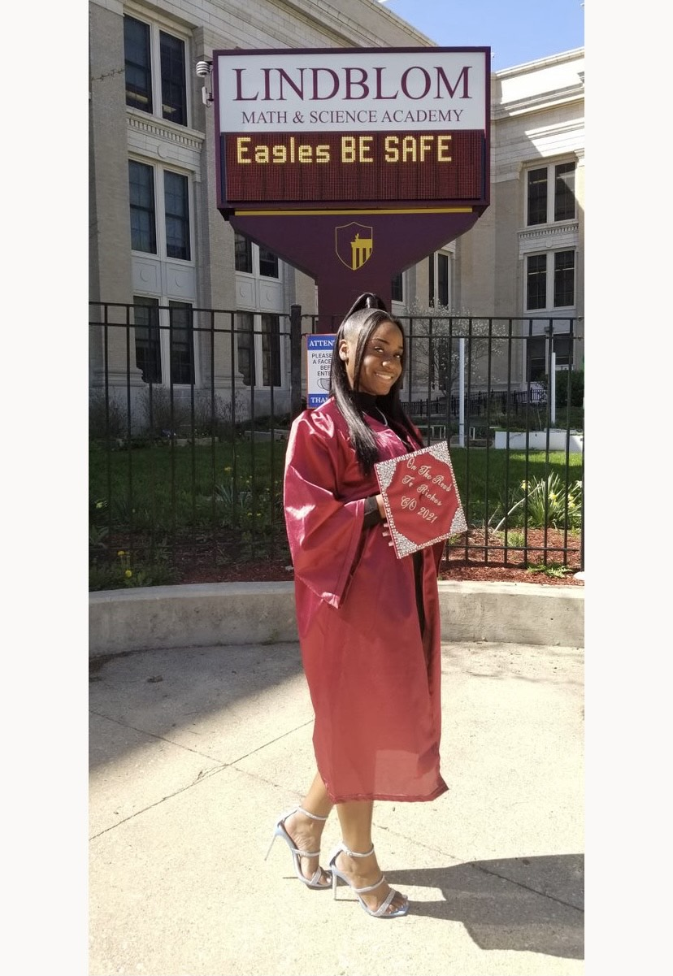
Zaryah Boyd – Lindblom High School

2021 High School Graduate Scholarship Winner

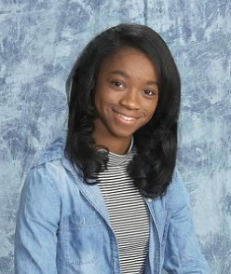

Jaylen Lockhart – Whitney Young High School

